**Gadget Sales REPORT**

1. **KPI’s**

1.**TOTAL REVENUE**

SELECT SUM(Sales) AS Total_Revenue from [Sales Data]

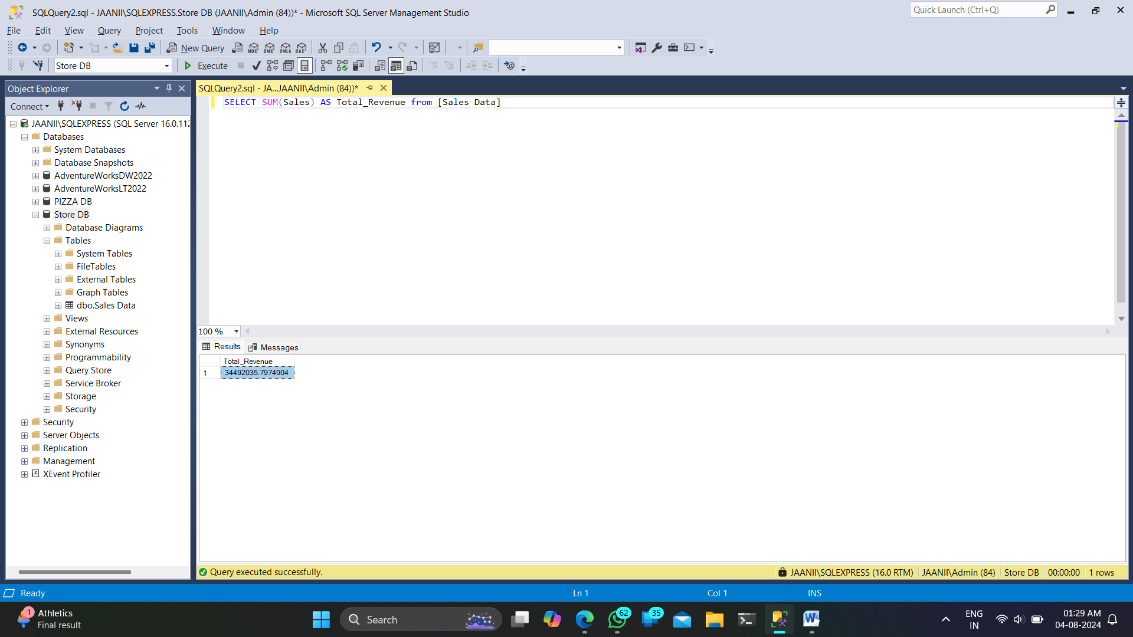

2.**Average Order Value**

SELECT SUM(Sales)/COUNT(Order_ID) as Avg_Order_Value from [Sales Data]

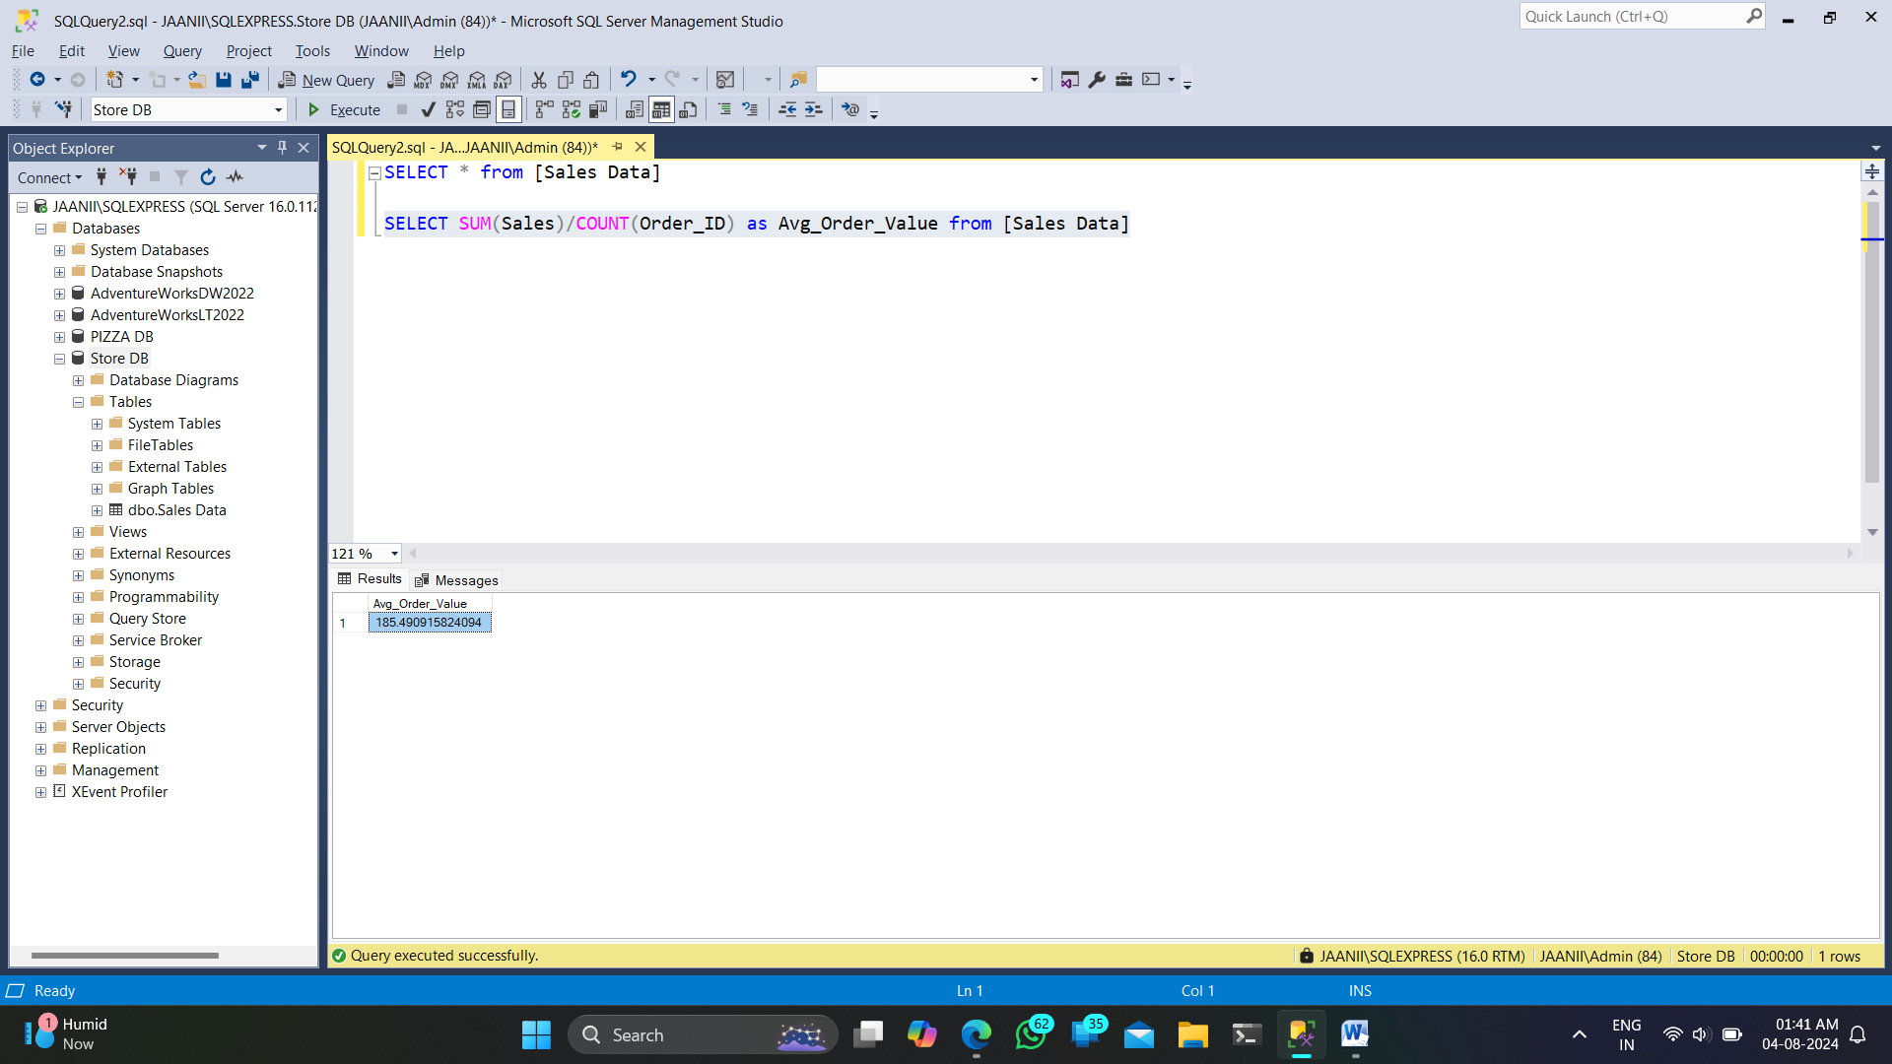

3.**Total Gadget Sold**

SELECT SUM(Quantity_Ordered)AS Total_Gadget_Sold from [Sales Data]

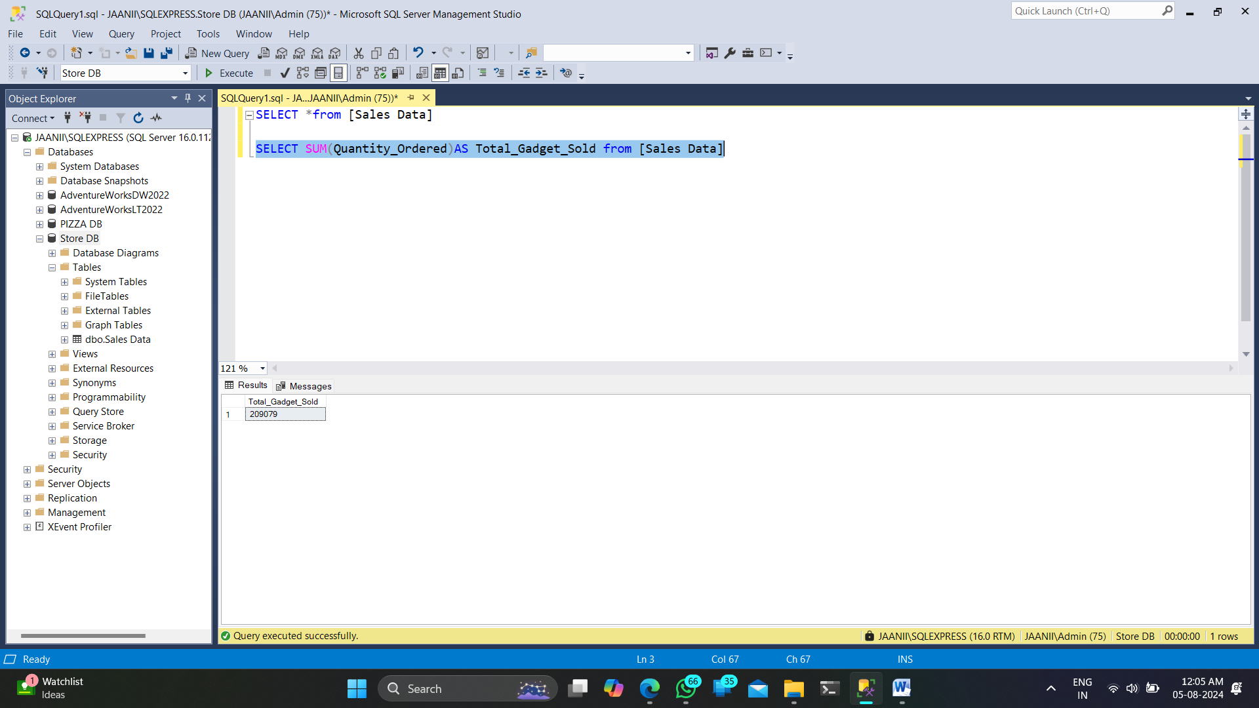

4.**Total Orders**

SELECT COUNT(Order_ID)AS Total_Orders from [Sales Data]

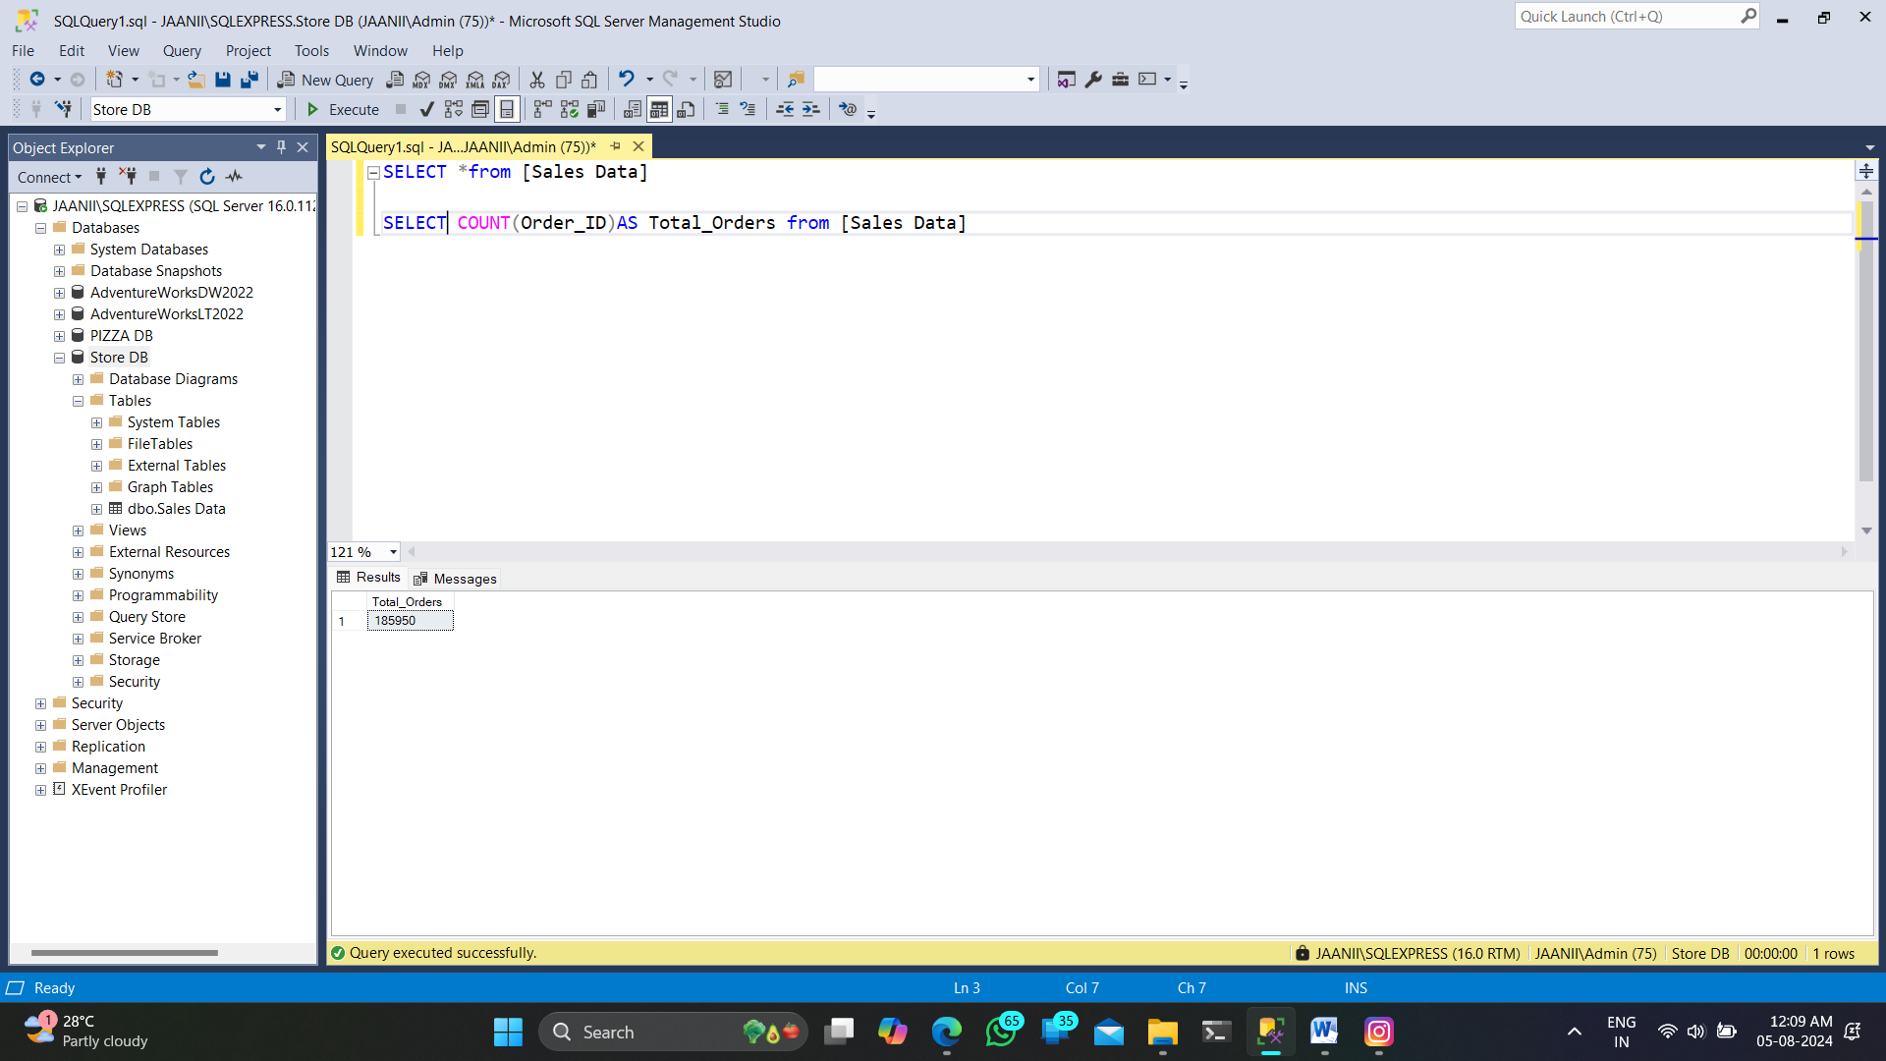

5.**Average Gadget Per Order**

SELECT CAST(CAST(SUM(Quantity_Ordered) AS DECIMAL(10,2))/

CAST(COUNT(Order_ID) AS DECIMAL(10,2)) AS DECIMAL(10,2)) AS Avg_Gadget_Per_Order from [Sales Data]

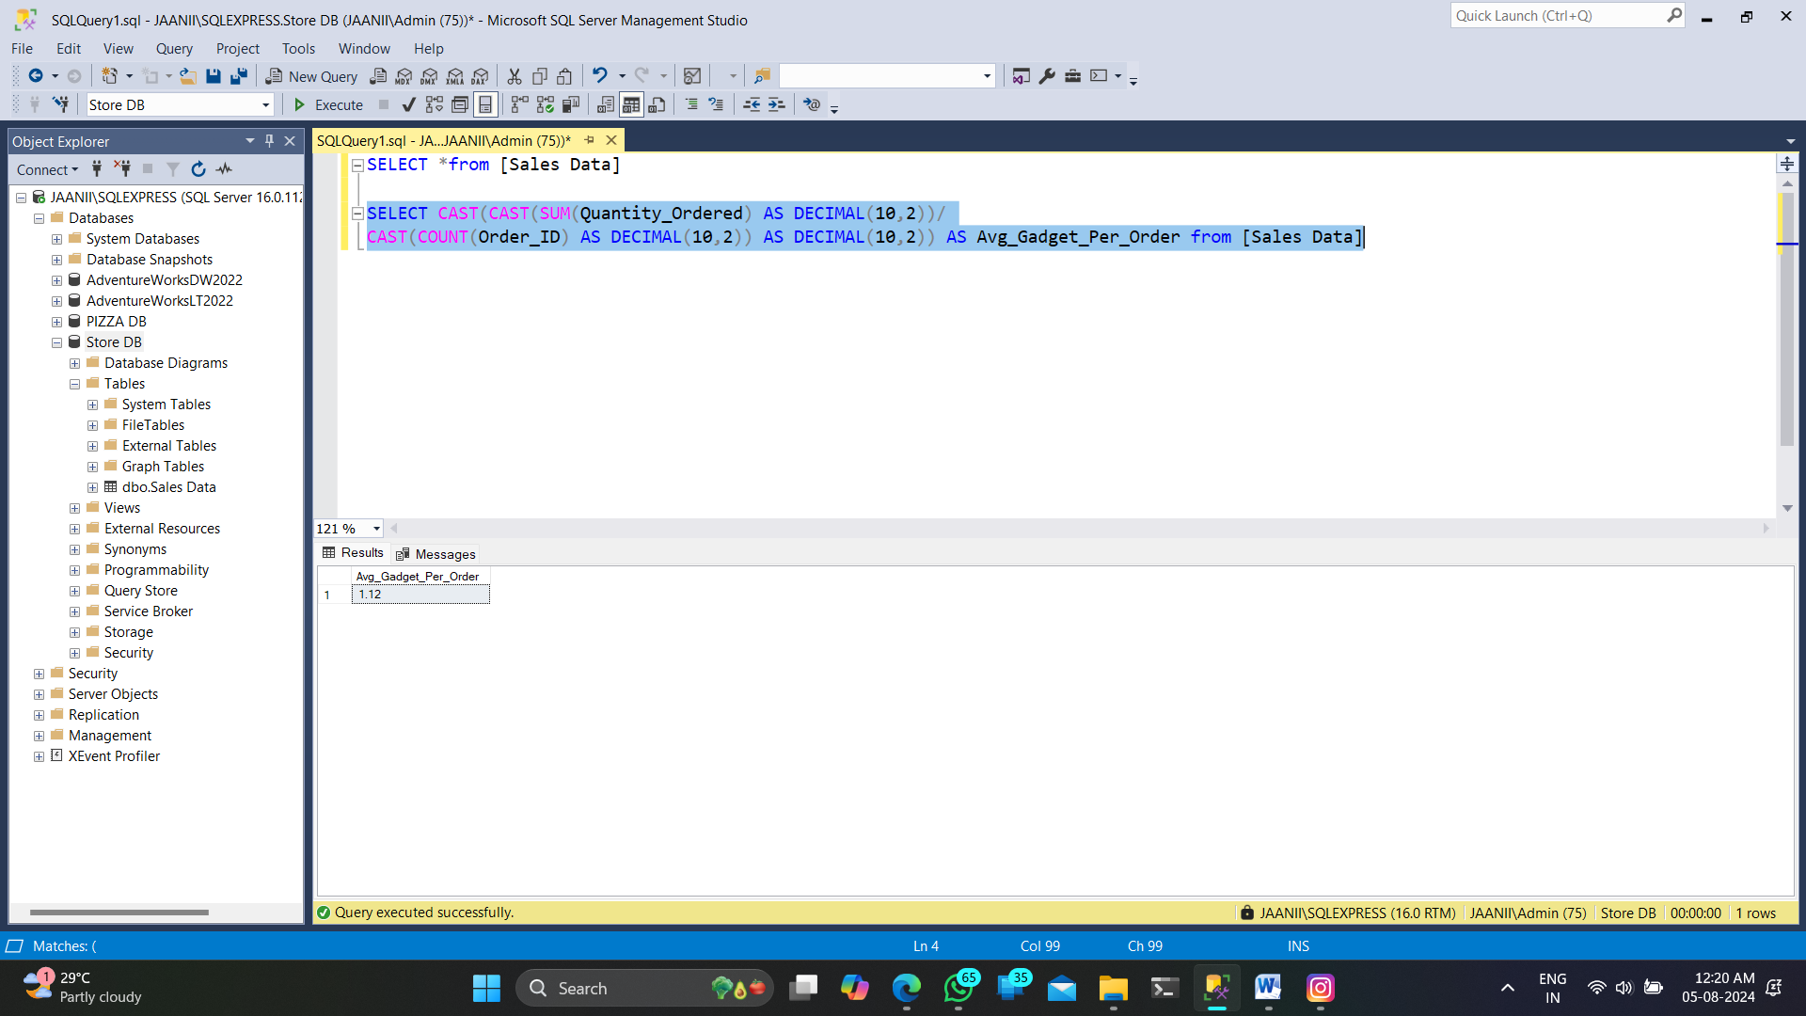

**B.CHARTS**

**1.Day-wise**

SELECT DATENAME(DW, Order_Date) as Order_Day,COUNT(Order_ID) AS Total_Orders

From [Sales Data]

GROUP BY DATENAME(DW, Order_Date)

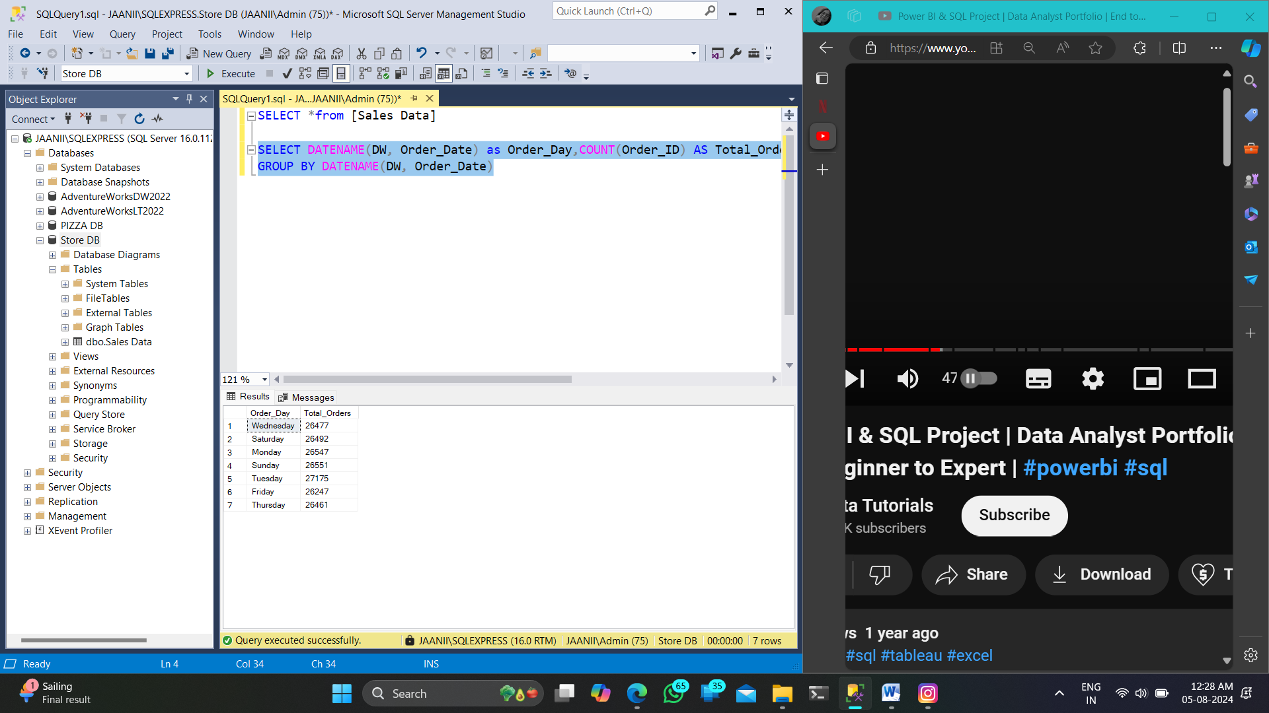

**2.Month**

SELECT DATENAME(MONTH,Order_Date) AS Month_Name, COUNT(Order_ID) AS Total_orders

from [Sales Data]

GROUP BY DATENAME(MONTH,Order_Date)

ORDER BY Total_orders

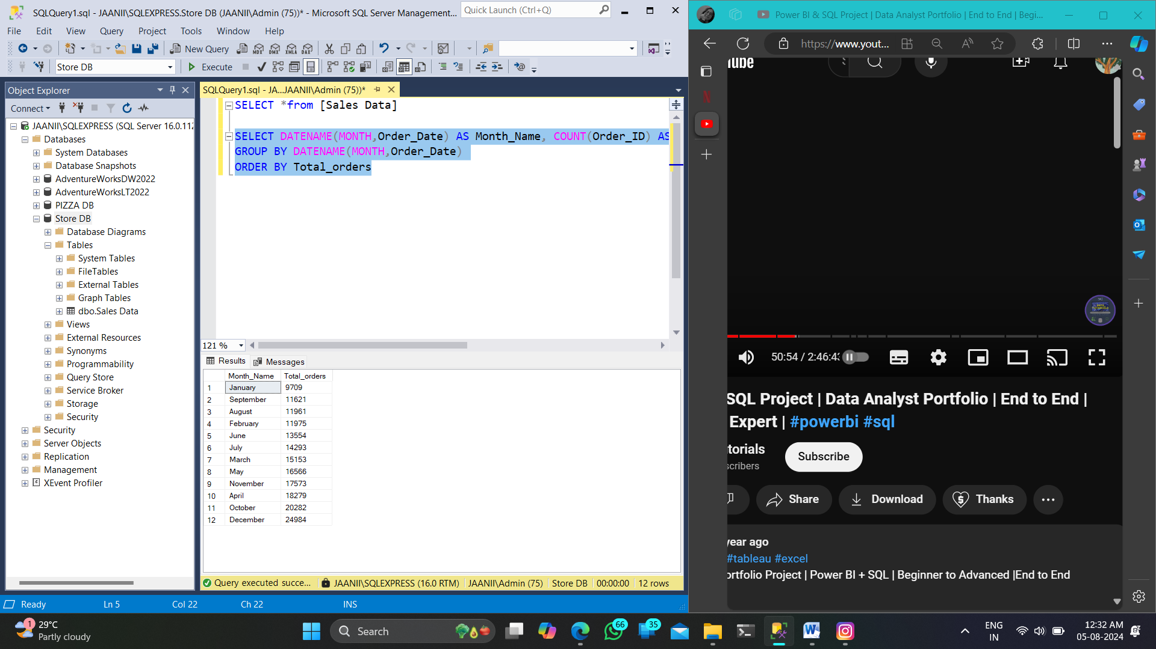

**3.TOP 5**

**i)Revenue**:

SELECT TOP 5 Product,SUM(Sales) AS Total_Revenue FROM [Sales Data] GROUP BY Product ORDER BY Total_Revenue DESC

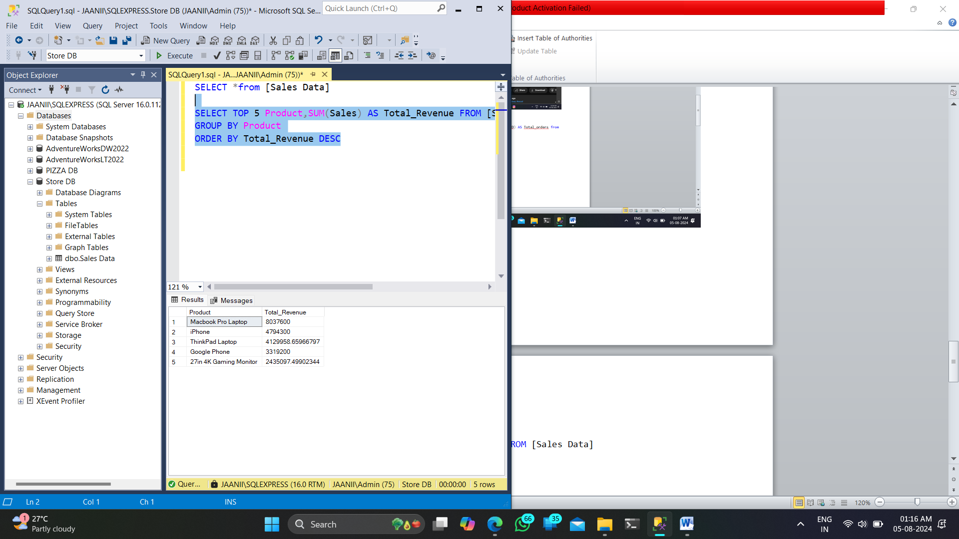

**ii)Quantity:**

SELECT TOP 5 Product,SUM(Quantity_Ordered) AS Total_Quantity FROM [Sales Data]

GROUP BY Product ORDER BY Total_Quantity DESC

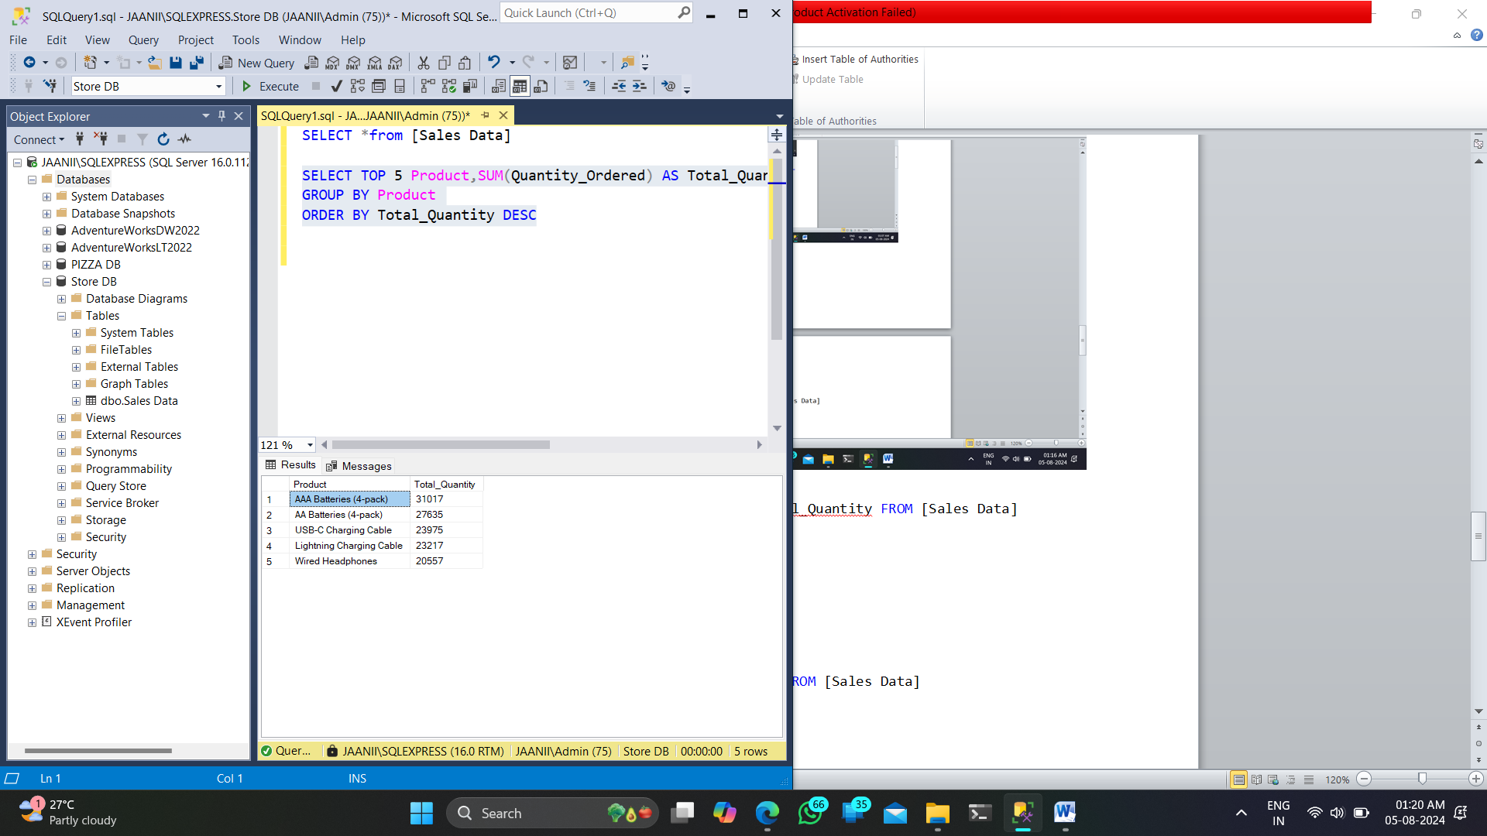

**4.Bottom 5**

**i)Revenue**

SELECT TOP 5 Product,SUM(Sales) AS Total_Revenue FROM [Sales Data]

GROUP BY Product

ORDER BY Total_Revenue

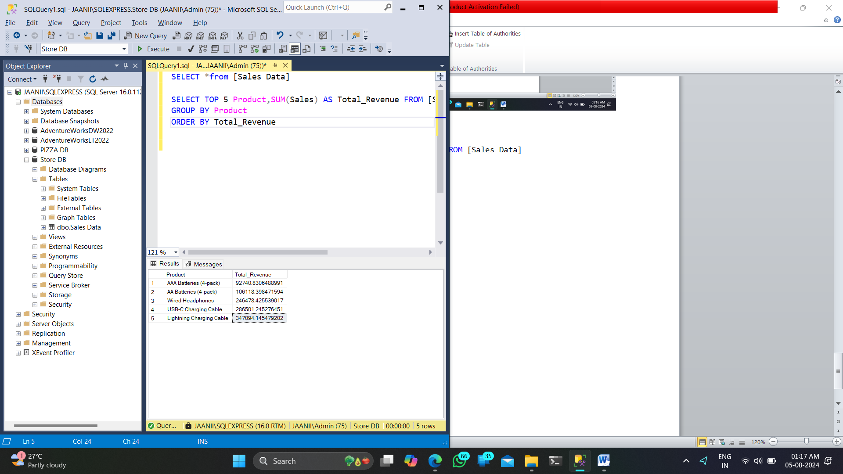

**ii)Quantity**

SELECT TOP 5 Product,SUM(Quantity_Ordered) AS Total_Quantity FROM [Sales Data]

GROUP BY Product

ORDER BY Total_Quantity

